
Gilthill Oracy Policy

Vision:- Children use their voice to speak clearly, confidently and respectfully. We build a community where every voice is valued and listened to.

Intent
Oracy plays a key role in teaching and learning at Gilthill. Children will be taught to talk and through talk to enable them to discuss, perform, debate and express themselves in a range of contexts and for a range of purposes. The children develop the confidence and skills to listen and talk effectively by valuing different views and engaging in meaningful conversations.
As part of our school community we promote all forms of communication and use many opportunities to encourage children to interact and learn through talk. Oracy is embedded across the curriculum and used to unlock new learning and challenge thinking.
We recognise that oracy in the classroom should be seen as a valuable activity and as such it plays an important role in collaborative learning activities starting with the early years as our children begin their school journey.
Many students enter school without the oracy skills expected for their age. We want to develop spoken language through the taught curriculum as well as playtimes, lunchtimes and extra-curricular activities.

Aims
- Children to speak clearly, with confidence and fluency
- Oracy to be at the heart of all teaching and learning activities
- Encourage respectful and productive relationships
- Standards of oracy will improve as children progress through the school
- Communication skills will enhance student engagement in learning achieving improved outcomes academically
- Promote social equity by ensuring that all students have the opportunity to develop their voice and be heard

Implementation
The oracy framework – the purpose of talk.
Oracy is central to all learning and by using the Oracy Framework (provided by Voice 21), we can address the four key strands which enable successful discussion, inspiring speech and effective communication.

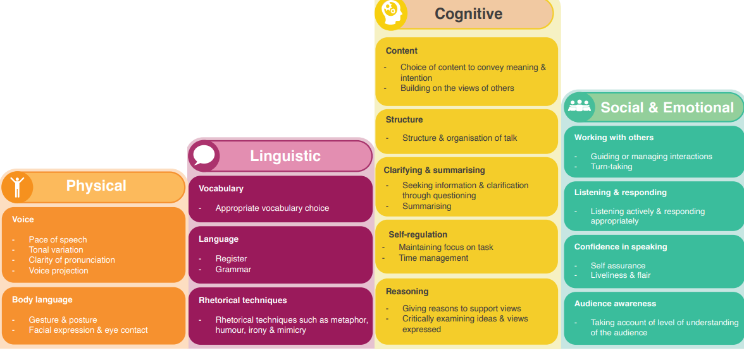

Different groupings.
When carefully planned and executed, discussion is a powerful tool for learning. During a discussion, students are actively involved in the development of their own knowledge and must constantly re-evaluate their position in relation to others. At Gilthill, we ensure that opportunities for talk are regular, purposeful, appropriately pitched and thoroughly planned to ensure that children are well prepared to meet expectations. Through using a variety of group protocols, we ensure that everyone in the group has the chance to have their say.
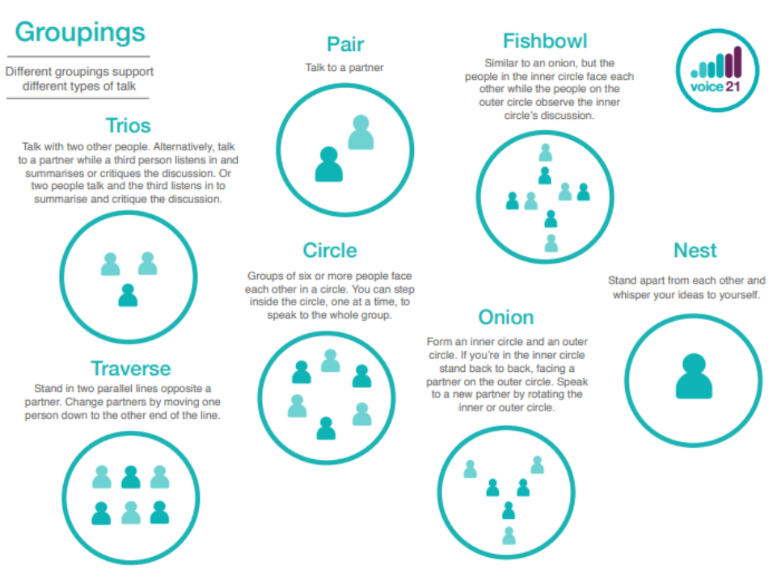

Use of talk tactics to scaffold talk.
We establish and model ambitious and challenging norms for talk, ensuring that children understand the expectations for talk within our classrooms. Talk Tactics are used in lessons to encourage pupils to think strategically about their contributions to group talk. Providing pupils with roles to play in discussions helps to manage talk and encourages the development of certain speaking and listening skills. This is further supported by the use of sentence stems and key vocabulary in lessons.
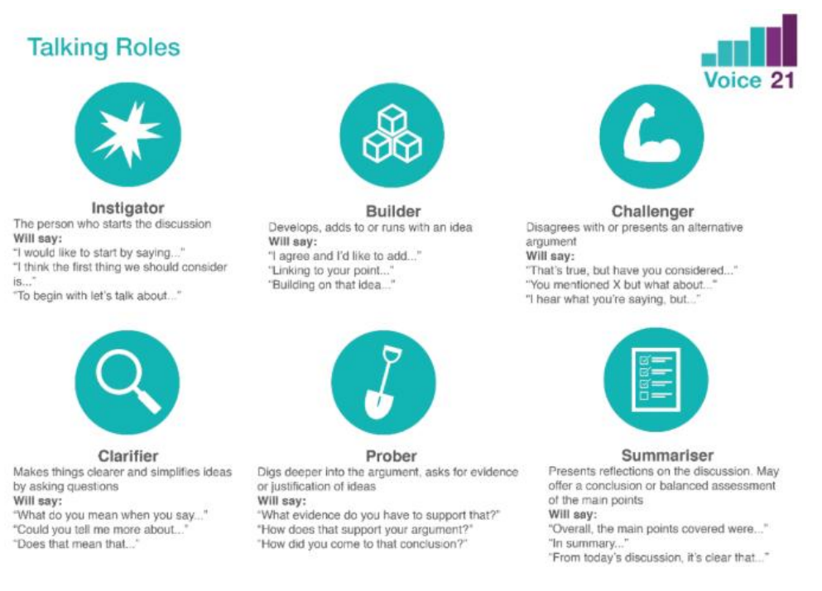

Springboards for talk.
Springboard activities support children to learn to talk and through talk.
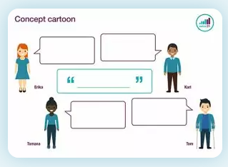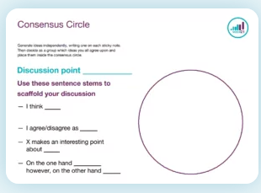
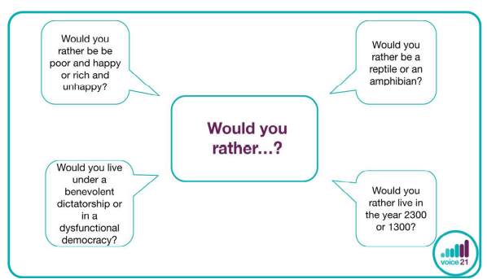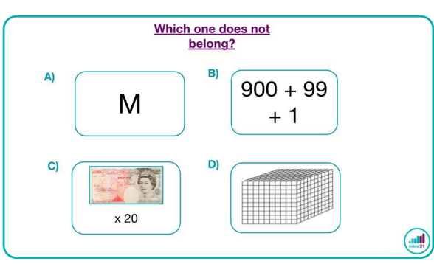

Teacher benchmarks.
These are a set of guiding principles outlining a high quality oracy education, when used they allow for children to learn to talk and through talk.
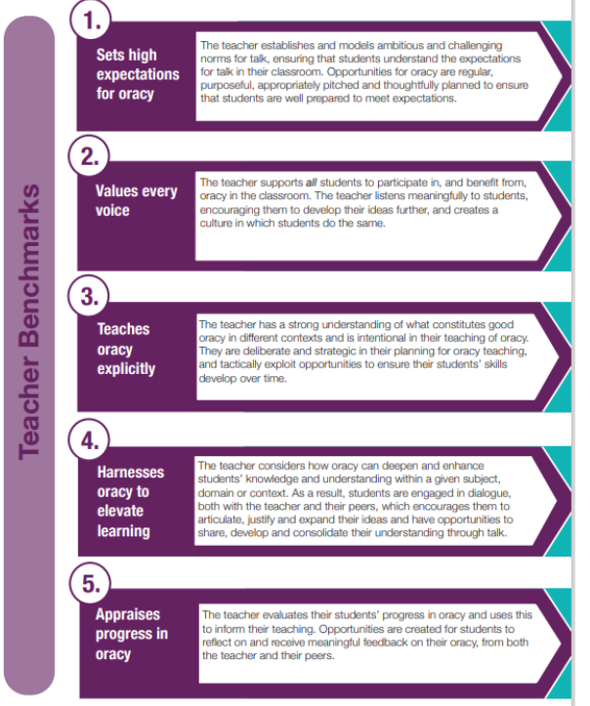

Impact.
By the time children leave Gilthill we want them to possess the oracy skills needed for their next stage of education and beyond. They will develop and embed a variety of speaking and listening skills.
A successful curriculum will:
- Increase a love of learning
- Improve academic outcomes for all pupils
- Enhance employability chances
- Support transitions
- Build confidence and well-being

Review – Jan 2027

