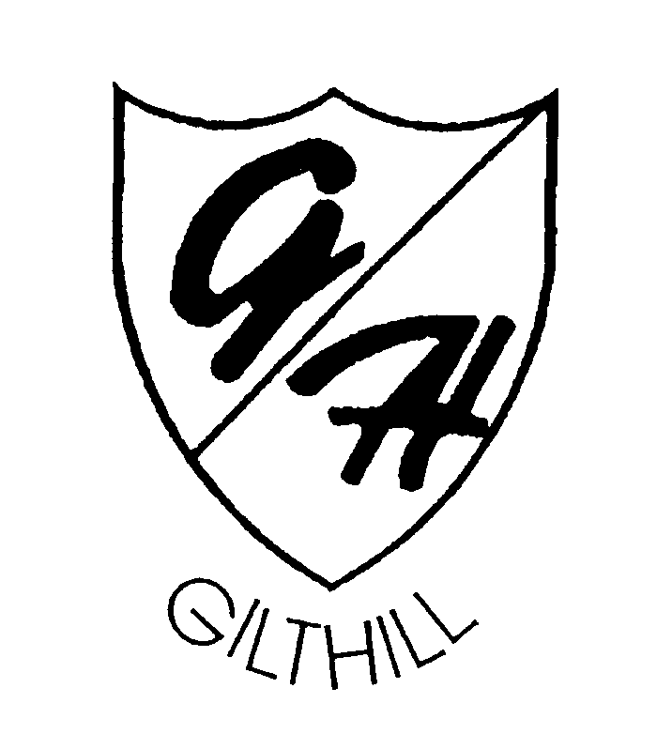
Art Learning Thread Progression Document 2026
Learning threads  (Breadth) | Reception | Year 1 |  | Year 2 |  | Year 3 |  |  | Year 4 |  | Year 5 |  | Year 6
Year A |  | What’s around us | What’s under our feet |  | What’s up | What makes something memorable? | Is it better to stand out or fit in? |  |  | It’s a kind of magic | Blood, chills and thrills | What a wonderful world |  | Healthy World
Year B |  | Wonderful Me | Wonderful World |  | Wonderful Events | Wonderful World -Blue Planet | Wonderful World – Green Planet Rainforests/Mayans |  |  | Rise of the machines -Inventions and inventors | Who loves chocolate? | Survive or Thrive |  | Space
Inspiration from the Greats | -Introduce artists | - Communicate things about myself using art. |  | -Create art based on artist’s work. |  | - Compare work of artists from different periods.  - Make notes about artists’ techniques.  - Evaluate own artwork. |  | - Explore how artists use a particular skill i.e figure and movement. |  |  | - Share feelings about an artist’s work.  - Express emotions through art.  - Attempt to replicate an artist’s style.  - Explain how to develop work further. |  | - Communicate emotions and a sense of self through art.  - Demonstrate my own style.  - Explain how my style has been influenced.  - Explain how work has been influenced.
Master techniques - painting | -Enjoy using a variety of tools including different size/ size brushes and tools i.e. sponge brushes, fingers, twigs.  -Recognise the primary colours being used.  -Mix colours to create secondary colours.  -Explore working with paint on different surfaces and in different ways i.e. coloured, sized and shaped paper. | - Identify and name primary and secondary colours.  - Create moods using colour. |  | - Mix secondary colours.  - Make tints and tones of different colours.  - Explain how the colours were made. |  | - Create a colour wheel to show colour mixing.  - Use brushes to create colour wash.  - Create pointillism effect using brushes.  - Create high quality final piece using colour wash and pointillism. |  | - Use marks, lines and colour with paint to create texture.  - Use watercolour paint to produce washes i.e Create water reflections using textures. |  |  | - Consider/explore how artists create moods.  - Create a montage displaying a range of moods and colours. |  | - Create paintings with accuracy and imagination.  - Explain and evaluate painting techniques and tools.
Master techniques - collage | -Enjoy different materials and explore different textures. | - Use cut and tear technique.  - Collect materials to use. |  | - Create a group photo collage.  - Work collaboratively as a group. |  | - Explain what montage collages are.  - Create montage collage by overlapping materials. |  | -Explain what 3D object collages are.  - Produce a 3D collage using everyday objects. |  |  | - Explore how shapes and colours are used in collage.  - Create collage using shape and colour. |  | - Create a collage based on previous experiences (children should use range of prior skills).  - Justify materials chosen for collage.
Master techniques - sculpture | -Enjoy a range of malleable media such as clay, papier Mache, Salt dough. -Introduction to clay – pinching, pulling, shaping rough forms. -Pushing objects into clay to make marks.  Using a sand tray to make temporary sculptures. | - Design a clay pot.  - Create a clay pot using different textures.  - Decorate a clay pot using paints. |  | - Design a double pinch pot product.  - Join two finger pots together to create art.  - Add detail to double pinch pot product. |  | - Work with life sized materials to create 3D art i.e outdoor materials. |  | -Manipulate clay into different positions.  - Sculpt clay into i.e the human form. |  |  | - Design a large-scale 3D form.  - Combine materials to make a large- scale 3D form.  - Use appropriate materials to add specific features and detail. |  | - Produce 3D artwork that allows audiences to interpret the meaning.  - Incorporate visual and tactile elements into 3D artwork.
Master techniques - drawing | -Introduce a range of drawing materials.  -Explore making marks, investigate and experiment.  -Produce lines of different thickness and tone using a pencil. | - Create different thicknesses using 2 grades of pencil (HB & 8B).  - Create observational drawings.  - Edit and improve drawings. |  | - Create patterns and textures using grades of pencils (HB, 4B & 8B).  - Create light and dark tones using charcoal and pastels.  - Choose appropriate tools and techniques to use. |  | - Sketch facial features showing expression.  - Show tones and textures using different grades of pencils (all grades). |  | - Sketch using tones and colours to show movement i.e human figure.  - Suggest adaptations and improvements to sketches.  - Use colour, shape and lines to show movement. |  |  | - Use a variety of techniques to add interesting effects ie  create reflections using marks, lines and shading.  - Use mirror reflection as a technique. |  | - Recall previous learning on drawing techniques.  - Create drawings with accuracy and imagination.  - Explain and evaluate drawing techniques and tools.
Master techniques - print | -Introduction to the process of printing. -Printing with found objects e.g. leaves, sponges, corks, building shapes, hands and feet.  -Use colour or shape to make patterns and repeats. | - Print using everyday objects.  - Create a repeated pattern using everyday objects. |  | - Explore using different printing techniques (pressing, rolling, rubbing, stamping).  - Create a mono-print (in the style of a designer). |  | - Design a printing block.  - Make a detailed printing block (using card and string).  - Use own printing block to make detailed print. |  | - Explore printing onto different materials.  - Create an accurate printing block to print using two colours. |  |  | - Use overprinting technique.  - Create effective piece of art using overprinting technique. |  | - Demonstrate experience in a range of printing techniques. - Create piece of printed art in own style.
Master techniques – digital media | Experiment with apps on ipad and features of simple painting program on desktop.  Make marks and pictures to communicate ideas | - Use a painting programme to create a picture.  - Use tools to create art. |  | - Change photo images to display different moods. |  | - Create mixed media piece of art, combining images and other media. |  | - Produce artwork with graphic and text. |  |  | - Adapt a digital image of a landscape using software. |  | - Create animated art images.
Learning Values
Ready | The children will develop ideas and learn about the commitment of artists and designers and what it means to commit to a piece of artwork or a design for a purpose. They will develop their creativity through the development of their own ideas and make it original. They will develop their curiosity by asking questions about styles, skills and materials. They will develop enthusiasm for completing a piece of artwork as it progresses.
Respectful | The children will continue to gain a greater understanding of the different styles of art and design, and they will learn to accept, care, appreciate and have an empathy for their work and the work of others. They will continue to become more reflective and learn to improve their own style and technique.  Gilthill’s Art learning threads are Developing ideas, Mastering techniques – drawing, painting, sculpture/collage, printing, textiles. Digital media. Inspiration from the greats.
Safe | The children will start to grow in confidence when using materials. They will learn to be responsible when working on new techniques and investigate new styles while continuing to have an awareness of the environment and the world around them. The children will also be involved in teamwork so will learn to co-operate with others and become adaptable to the ideas of others. Ready- The children will continue to grow in independence and show their ability to go with their own ideas, be a risk–taker and show the confidence to carry an idea forward and face any pitfalls.  Taking inspiration from the greats in Art and Design

