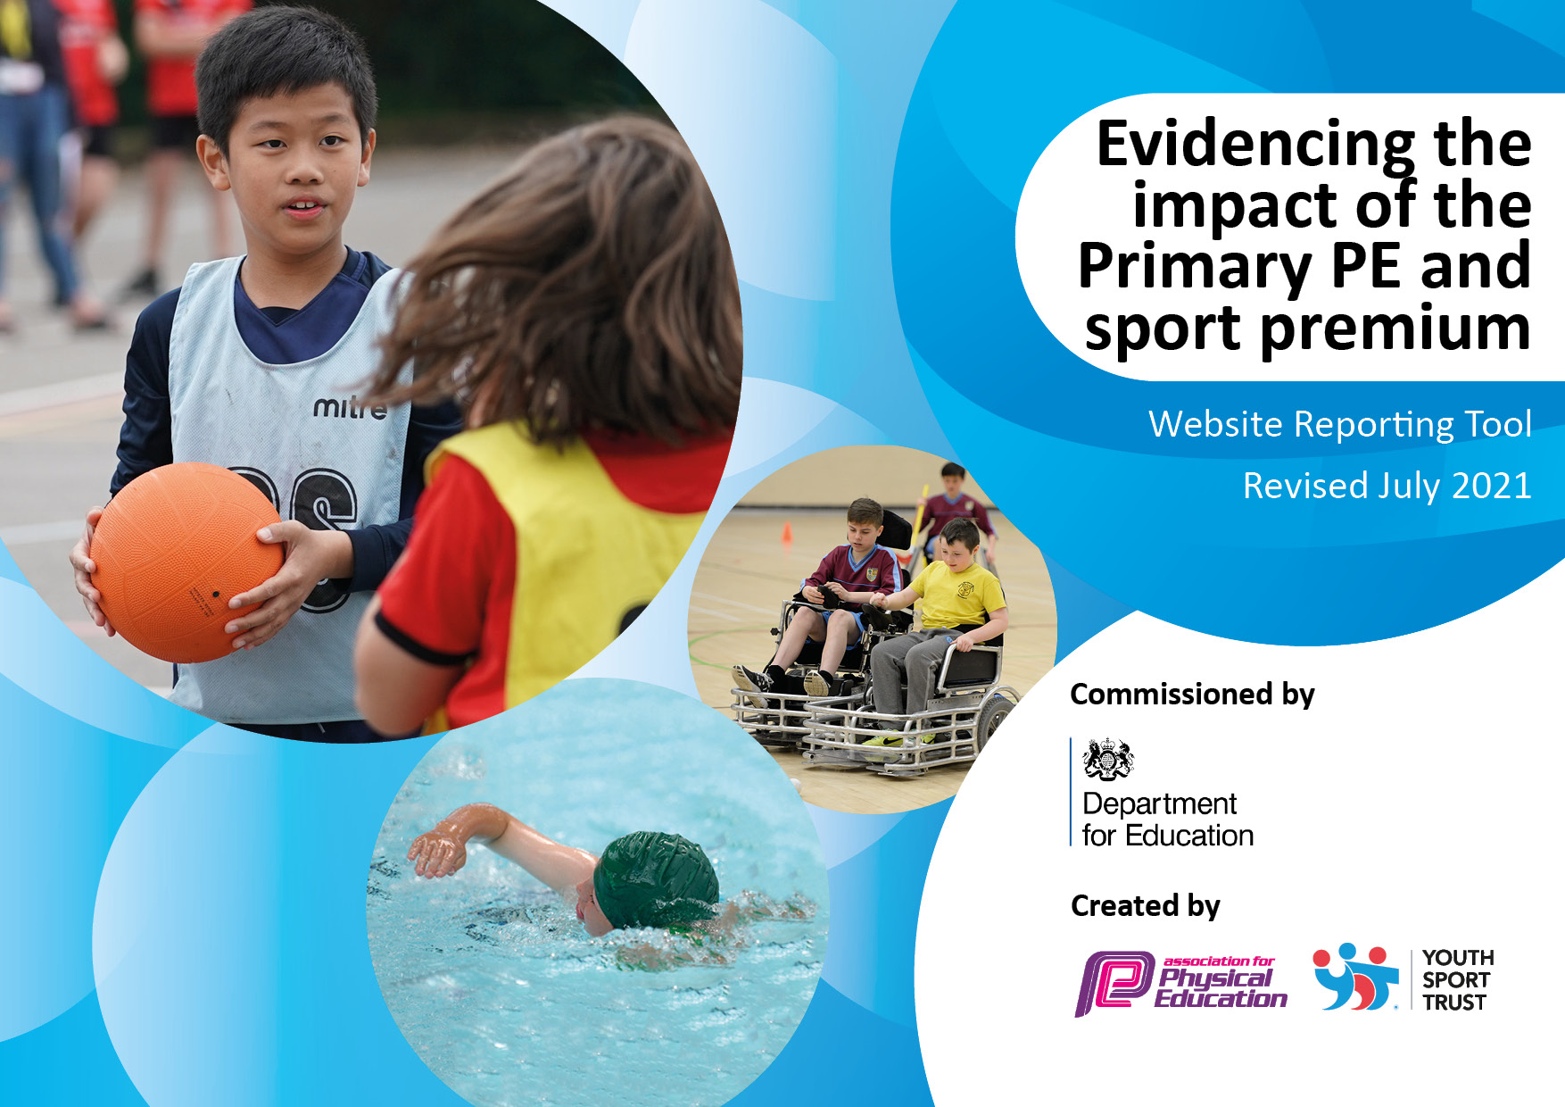

Gilthill Primary School

Sports Premium Funding

2021 - 2022

|  |  |
| --- | --- |
| Total amount carried over from 2019/20 | £ 1,500 |
| Total amount allocated for 2020/21 | £ 19,240 |
| How much (if any) do you intend to carry over from this total fund into 2021/22? | £ 1,840 |
| Total amount allocated for 2021/22 | £ 17,740 |
| Total amount of funding for 2021/22. To be spent and reported on by 31st July 2022. | £ 19,580 (Total spend £19,902) |

|  |  |
| --- | --- |
| Meeting national curriculum requirements for swimming and water safety. |  |
| What percentage of your current Year 6 cohort swim competently, confidently and proficiently over a distance of at least 25 metres? | 85% |
| What percentage of your current Year 6 cohort use a range of strokes effectively [for example, front crawl, backstroke and breaststroke]? | 85% |
| **What percentage of your current Year 6 cohort perform safe self-rescue in different water-based situations?** | 85% |
| Schools can choose to use the Primary PE and sport premium to provide additional provision for swimming but this must be for activity **over and above** the national curriculum requirements. Have you used it in this way? | Yes/No |

**Swimming Data**

Please report on your Swimming Data below.

**Details with regard to funding**

**Action Plan and Budget Tracking**

Capture your intended annual spend against the 5 key indicators. Clarify the success criteria and evidence of impact that you intend to measure to evaluate for pupils today and for the future.

|  |  |  |  |  |  |
| --- | --- | --- | --- | --- | --- |
| **Academic Year:** 2021/22 | | **Total fund allocated:** 19,580 | **Date Updated:** | |  |
| **Key indicator 1:** The engagement of all pupils in regular physical activity – Chief Medical Officers guidelines recommend that primary school pupils undertake at least 30 minutes of physical activity a day in school  **Key indicator 2:** The profile of PESSPA being raised across the school as a tool for whole school improvement  **Key indicator 3:** Increased confidence, knowledge and skills of all staff in teaching PE and sport  **Key indicator 4:** Broader experience of a range of sports and activities offered to all pupils  **Key indicator 5:** Increased participation in competitive sport | | | | | Percentage of total allocation: |
| 1 – 10.6%  2 – 28.4%  3 – 48.3%  4 – 7.3%  5 – 5.4% |
|  | **Intent** | **Implementation** | | **Impact** |  |
| 1, 2, 4 | For all KS2 children to participate in x2 20 minutes active ‘Wellbeing Event’ (on top of their existing timetabled PE sessions) per week. The Wellbeing Event incorporates either 20 minutes sustained running or ‘fast’ paced walking. *Last academic year, this activity was purely a running event. However, in 2021 – 22 we amended the activity to ensure greater participation and inclusion for all pupils. | Timetabled x2 20-minute slots per week (in addition to timetabled PE sessions).  KS2 staff participated in training (led by PE lead) on running and facilitating the Wellbeing Events. | £0  £0 | All KS2 children participate in a 20min sustained and active wellbeing session, at least x2 times week, additional to their timetabled PE slots.  The active participation in the events has increased due to a more inclusive approach. Staff have witnessed increased confidence and self esteem with regards to physical activity in KS2 children  There are fewer consistent non-participants in the events (from 10% to 2.5%)  As a result of confident and knowledgeable support from KS2 staff (led by PE lead) ALL pupils, irrespective of their special educational needs and disabilities made excellent progress in line with their prior learning and ability.  The enjoyment of PE increased participation in wider activities (84% of all pupils attending one or more after school clubs and 85% of PP children attending at least one club). | The Well being event is an embedded part of our curriculum offer and will continue next academic year. |
| 2, 4, 5 | For our children to take part in disability awareness coaching and participate in a competitive interschool sporting disability awareness events. | X 1 day wheel chair basketball coaching sessions for years 3-6 (x1 hour sessions)  X1 after school club for 20 children (Year 5)  X 1 day wheel chair basketball coaching sessions for years R-2 (x1 hour sessions)  X1 day working with another local school on an interschool wheelchair basketball competition. | £672 | Children understand the challenges and the achievements of disabled athletes. Children are exposed to a wide range of additional skills that they may not have experienced.  Development of co-operation/working in groups/desire to learn in the year group that took part in interschool competition (Year 5) | Next year, our Trust has arranged for Primaries to access a 6-week block of wheelchair basketball. This will ensure the skills are developed and children will get the opportunity to access the sport as they move through school. More opportunities for interschool competitions and participation. |
| 2, 3 | Appointed a qualified sports coach to ensure children were accessing quality physical education lessons and staff (TA’s and teachers) were being upskilled in knowledge, understanding and techniques to raise confidence in teaching PE. | Qualified sports coach was employed for 1 day per week.  Slots were timetabled so all children and staff had access to quality PE.  Staff observed sports coach lessons to upskill and build confidence in teaching PE.  Sports coach supported newly appointed PE lead in leadership of physical education throughout school, building confidence and knowledge.  Sports coach led a variety of sports after school clubs throughout the year from R to Year 6.  Sports coach led sessions to develop basic sporting skills in children who show lower attainment within lessons.  Sports coach led sessions preparing children for competitive regional and Trust wide sporting events. | £6120 | Increased confidence, self-esteem, and a real desire to learn. The enjoyment of PE increased participation in wider activities within school and after school clubs’ participation.  Lower attaining children secured fundamental sporting skills, boosting confidence to prepare them for participation in sporting events.  PE subject lead has increased confidence leading to good leadership of the subject throughout school. Staffs’ skills and knowledge of PE is increased through access to trained staff.  Gilthill pupils participate in a variety of region and Trust wide sporting competitions for example football tournaments (achieving second place in tournament), Cross country competitions (KS2U girls came second overall in the competition with individual medals also awarded). | Access to sports coach to continue in 2022-23.  Staff to take a lead in delivering PE lessons using their developing expertise (supported by Sports coach). |
| 1, 4 | Qualified sports coach to lead one afterschool club per week for the duration of the academic year, from Year R to Year 6. Children to access quality sports sessions, developing their skills in a variety of different sports. | After school sports provision carefully planned out by SLT for the academic year.  Planning ensures all year groups in school will be able to access an after-school sporting club if they wish.  Sporting clubs were planned to support timetabled regional and Trust wide sporting competitions.  Participation of vulnerable groups in afterschool sporting clubs was monitored and encouraged. | £950 | Children are more skilled in a variety of sports.  Participation in after school clubs throughout school is high. 84% of all children attended at least one after school club this year. 85% of PP children attended at least one after school club this year. | Access to continue next year.  Children to be surveyed to ascertain which sporting activities they would like to participate in. This information to be used as part of the ongoing planning of after school sporting activities. |
| 4 | Bikeability - Children in UKS2 offered the opportunity for 2 hours (per class) of Level 2-3 cycle instruction provided by Via East Midlands. | Sessions offered for Year 5 and Year 6 pupils. | £0 | Participation levels high in both Year 5 and year 6. Children have increased road and cycle safety. | Bikeability will continue to be offered to UKS2 pupils. |
| 4 | Balance bike sessions for EYFS pupils to develop coordination and gross motor skills. | X6 week block for our new EYFS pupils in Autumn 1 | £240 | EYFS pupils have increased gross motor and coordination skills. Their coordination and stability is improved leading to a greater success when learning to ride a bicycle. | Children will go on to access bikebaility in KS2 |
| 4 | To provide UKS2 catch up swimming sessions for identified children who have not achieved the required level to ensure a greater % of our children achieve the expected standard in swimming by the end of KS2. | X4 week catch up swimming sessions. Children identified from Year 4-6. | £0 | 85% of our current Year 6 cohort have achieved the expected standard in swimming. | Target of 90% set for next year’s year 6 cohort. |
| 5 | Swimming Gala - To provide additional coaching and practice time for children who show high attainment in swimming with the intention of best preparing children for the district swimming gala. | PE lead/swimming instructors/sport coach to identify pupils who would benefit from additional preparation time.  PE lead to accompany children on the practice sessions to ensure swimming gala rules and regulations are adhered to. | £200 | Gilthill achieved second place in the regional (small schools) swimming gala. Children with high potential were identified through the trials and practice sessions. | Children identified as potential participants for future gala attendance. |
| 1, 2 | Purchasing renewed sporting equipment to ensure our children can participate and develop in a variety of sports. | Purchased new goal posts (for competitive and teaching sports), Netball nets, dodge balls, basket balls and hockey balls and other sporting equipment to ensure high quality and varied sports can be taught. | £600 | School has the relevant equipment to ensure high quality and varied physical education. Children are able to practice and refine their skills in a number of sports using the correct equipment. | High quality equipment purchased and replenished to ensure it lasts for a number of years. |
| 1, 2, 4 | To ensure a variety of staff led after school activities that promote physical development and wellbeing. | Chance to dance after school club led by a qualified dance teacher. Club culminated in a regional ‘Chance to Dance’ showcase of skills.  Gardening club for KS2 children promoting healthy eating, sustainability and healthy lifestyle choices | £0 | Staff expertise is used to enhance our physical education extracurricular offer. Children have the opportunity to participate and excel in modern dance classes and to showcase their skills to a live audience.  Children have a deeper understanding of how to grow their own food and the importance of choosing healthy eating choices. Attendance of clubs is oversubscribed as children have desire to participate. | Planters were used to plant vegetables. These can be maintained and developed by future gardening groups.  Full time staff member is also a qualified dance teacher who is able to continue to offer the club in future years. |
| 2, 4, 5 | School to participate in and host a number of regional and Trust wide sporting competitions.  Gilthill will participate in all the District Sports events offered. | Over the academic year, Gilthill to host:  Netball tournament  Football matches  Rounders competition  Gilthill will also attend a number of sporting competitions hosted at other venues:  Competed in District Sports event  X2 cross country events  Regional Football tournament  Local girls football tournament  Inclusive games (KS1) at local secondary school  Regional swimming gala | £100 District Membership Travel costs for events £200  Supply costs to attend events £200 | Gilthill pupils participate in a variety of region and Trust wide sporting competitions, with some success, for example:  football tournaments (achieving second place in one tournament),  Cross country competitions (KS2U girls came second overall in one competition with individual medals also awarded)  Gilthill came second in the regional (small schools) swimming gala  Gilthill has attended all regional events this year, bar one. | Membership to District Sports to continue next year.  Gilthill will continue to participate in sporting competitive events both regional and Trust wide. |
| 3, 4 | Staff new to Year 6 to receive training in delivering a 5-day, school led residential visit to Cloughton. | Experienced member of staff to accompany new staff member on the residential to provide day to day training on the event.  In school planning time with experienced member of staff to plan physical activities throughout the 5-day residential. | £800 (supply costs) | New staff are confident to plan and lead a 5-day school residential visit. Activities include orienteering, rock pooling, coastal walks and team games. Children benefit from trained staff who can use their knowledge to enhance the educational experience as well as developing confidence, independence and physical ability. | New staff are trained in the planning and delivery to ensure we can continue to run the event in coming years. |
| 1, 2, 3, 4 | X5 staff members to undertake training to become official Drumba instructors. This will up-skill our own staff knowledge and understanding so they can confidently disseminate to all staff, thus increasing their knowledge and confidence. | X5 staff members to take part in a 6-week training programme (x1 day per week in school with their own class)  X5 staff to attend half day INSET training on Drumba Theory  X1 day celebration event where all 5 members of staff are observed teaching various Drumba exercises  Drumba staff to train a group pf our current Year 5 children as mini Drumba instructors.  Purchase class set of official Drumba equipment x30 plus teacher sets  Drumba staff to continue to add new songs and routines to build our repertoire. Staff to provide guidance and support to our school staff. | £1350 licencing  £6,166 Staff training  £2304 purchasing equipment | Trained staff are confident in the delivery of Drumba in school. Children’s enjoyment and participation is high. Their coordination, rhythm and gross motor skills are increased.  Children are trained to help deliver Drumba raising the profile of sport in school and adding to our whole school improvement of sports provision.  Trained staff are able to train additional staff, building up our capacity to deliver Drumba  Trained staff are confident in delivering Drumba to community groups e.g., mother and toddler groups (particularly aimed at our new parents), after school sessions for parents, a Governor Drumba session etc.  Drumba is showcased in our community events e.g., Summer Fayre and other PTA events. | PE lead, who is now Drumba trained, has devised a whole school plan for next academic year to ensure regular and progressive sessions take place throughout the year with all children in school accessing Drumba at some point in the school year. |
| 2, 3, 4 | To appoint an outdoor learning lead to develop our whole school outdoor learning offer. | Staff meeting time allocated for outdoor learning lead to disseminate resources and teaching ideas for outdoor learning.  Outdoor learning lead to set up termly whole school activities, for example orienteering activities.  MPT planning to highlight outdoor learning lessons per half term.  Teams file set up to share teaching resources, personal CPD websites and blogs and lesson ideas. | £0 | Teachers are confident to plan, resource and lead outdoor learning activities (at least one per half term). These are planned alongside termly learning themes. Teachers feel supported by Outdoor learning lead for advice and expertise to ensure lessons are relevant and our outdoor space is used to deliver curriculum objectives effectively.  Children are benefiting from active learning in the outdoors. | Outdoor learning lead to monitor planned outdoor learning and develop an outdoor framework to compliment our curriculum. |

|  |  |
| --- | --- |
| Signed off by N Allison | |
| Head Teacher: | N Allison |
| Date: | June 2022 |
| Subject Leader: | Jade Bult |
| Date: | January 2022 |
| Governor: |  |
| Date: |  |